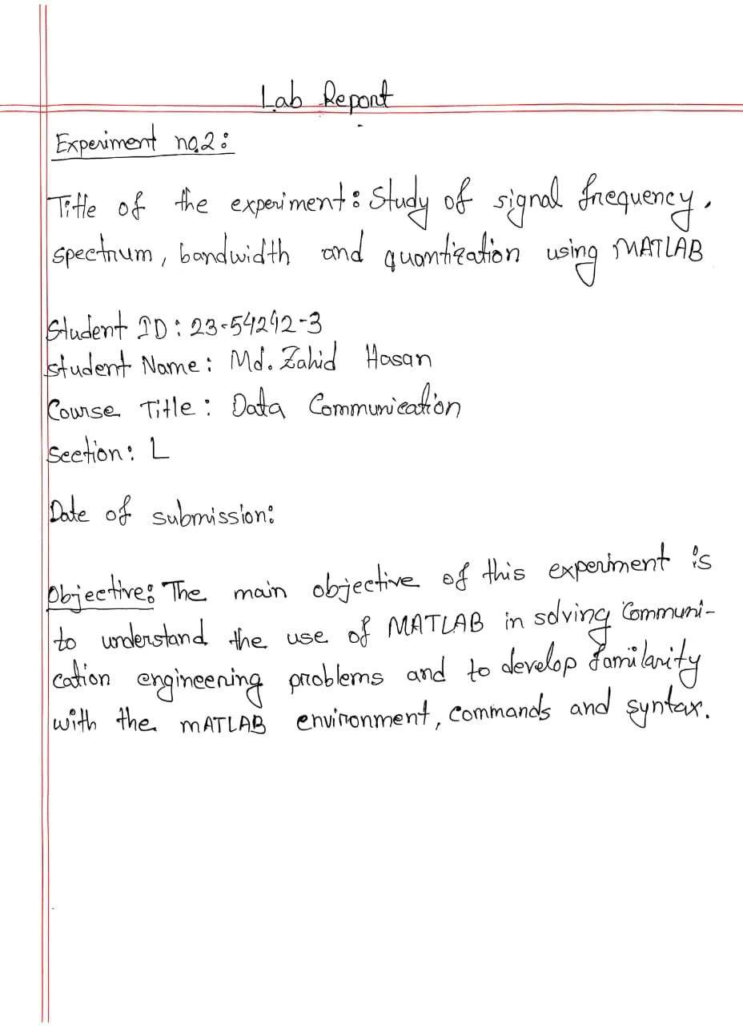
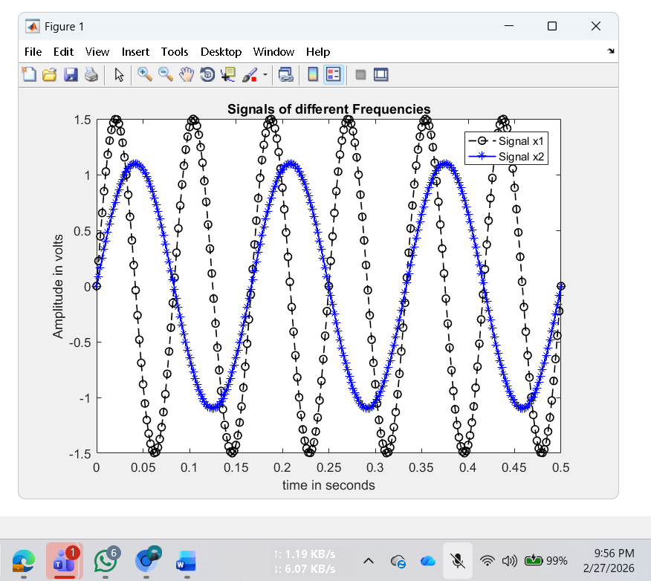
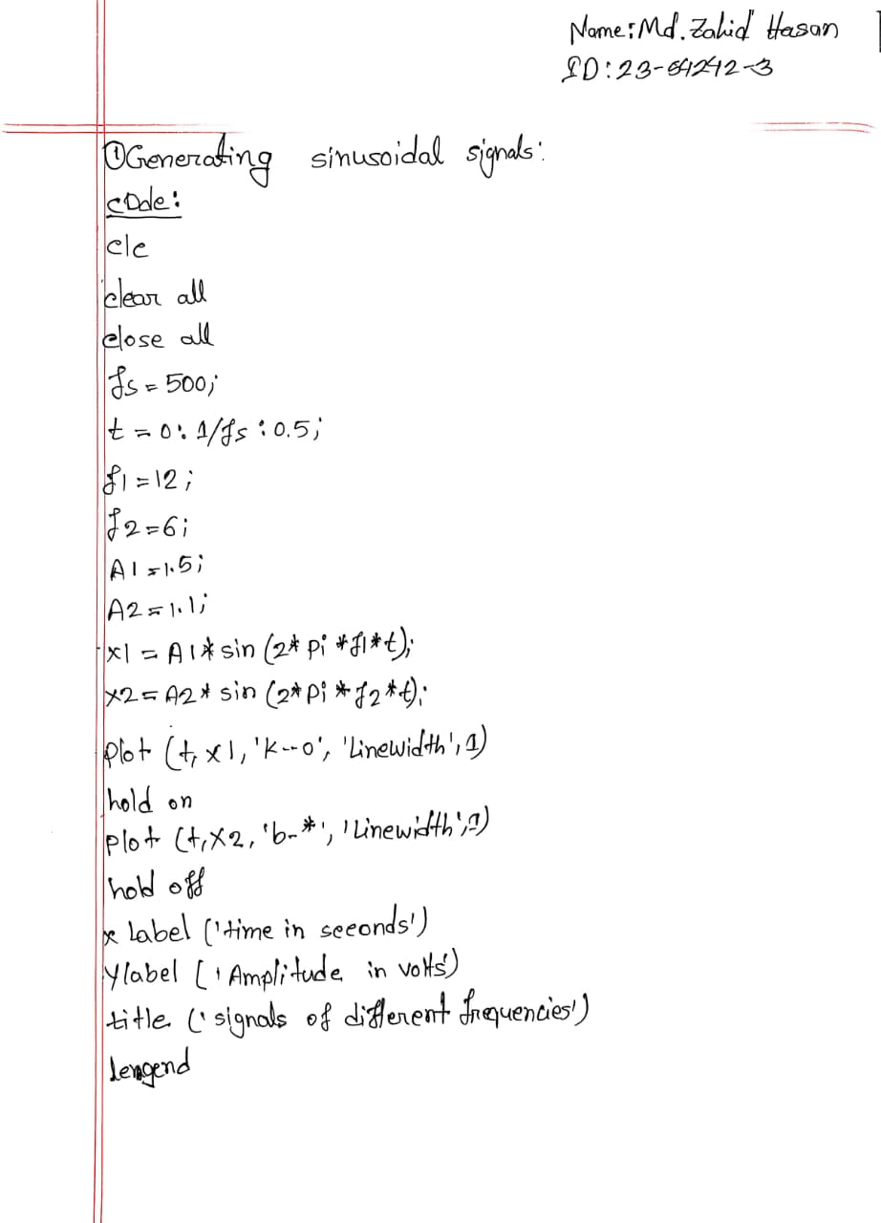
Name: Md. Zahid Hasan
ID: 23- 54242-3
MATLAB Code: Signal represented as frequency domain
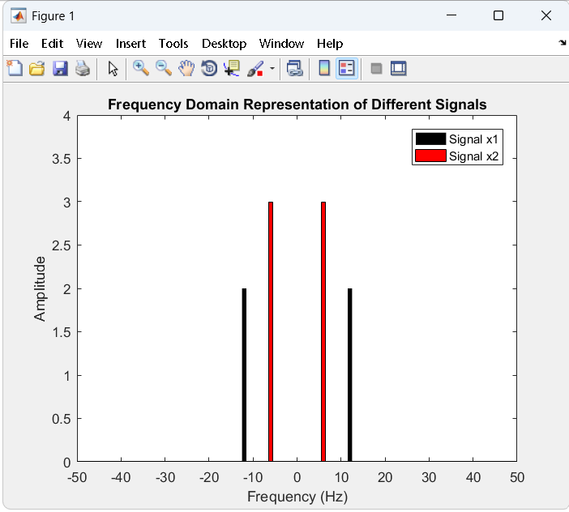
clc
clear all
close all
fs = 5000; % Sampling frequency
t = 0:1/fs:2; % Time duration
f1 = 12; % Frequency of first signal
f2 = 6; % Frequency of second signal
A1 = 2; % Amplitude of first signal
A2 = 3; % Amplitude of second signal
x1 = A1*sin(2*pi*f1*t); % First Signal
x2 = A2*sin(2*pi*f2*t); % Second Signal
nx = length(t); % Total number of samples
%Take fourier transform
fx1 = fft(x1); % Frequency analysis is done here
fx2 = fft(x2);
% Apply fftshift to put it in the form we are used to (see
% documentation)
fx1 = fftshift(fx1)/(nx/2); % Axis correction and scaling are
% done here
fx2 = fftshift(fx2)/(nx/2);
% Next, calculate the frequency axis, which is defined by the
% sampling rate
f = linspace(-fs/2,fs/2,nx);
% fft function in Matlab returns complex numbers that has both
% frequency and phase information
% we will only plot absolute values of the
% fft transformed variables
% to see the frequency domain representations
bar(f, abs(fx1),2,'k')
hold on
bar(f, abs(fx2),2,'r')
hold off
axis([-50 50 0 4])
xlabel('Frequency (Hz)');
ylabel('Amplitude');
title('Frequency Domain Representation of Different Signals');
legend('Signal x1','Signal x2')

Name: Md. Zahid Hasan
ID: 23- 54242-3
Class Task:
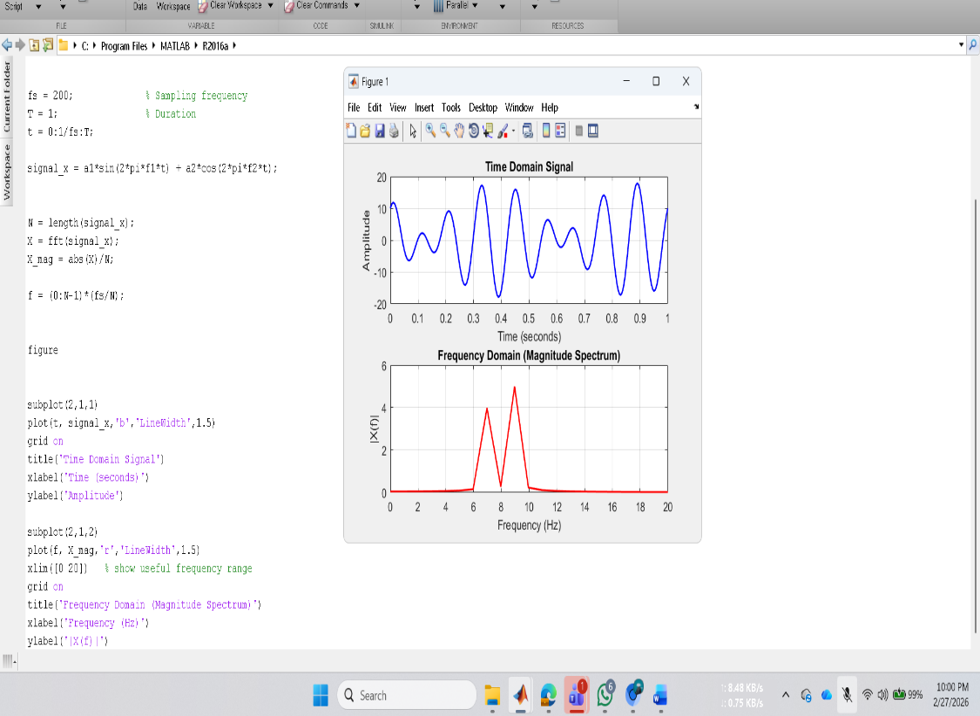
MATLAB Code:
>> clc;
clear;
close all;
%% ====== From ID: 23-54242-3 ======
a1 = 8;
a2 = 10;
f1 = 7; % Hz
f2 = 9; % Hz
fs = 200; % Sampling frequency
T = 1; % Duration
t = 0:1/fs:T;
signal_x = a1*sin(2*pi*f1*t) + a2*cos(2*pi*f2*t);
N = length(signal_x);
X = fft(signal_x);
X_mag = abs(X)/N;
f = (0:N-1)*(fs/N);
figure
subplot(2,1,1)
plot(t, signal_x,'b','LineWidth',1.5)
grid on
title('Time Domain Signal')
xlabel('Time (seconds)')
ylabel('Amplitude')
subplot(2,1,2)
plot(f, X_mag,'r','LineWidth',1.5)
xlim([0 20]) % show useful frequency range
grid on
title('Frequency Domain (Magnitude Spectrum)')
xlabel('Frequency (Hz)')
ylabel('|X(f)|')
Name: Md. Zahid Hasan
ID: 23- 54242-3
MATLAB Code: Example of Bandwidth calculation
fs = 8000; % Sampling frequency
t = 0:1/fs:1-1/fs; % Time duration
cx = 1.1*sin(2*pi*100*t) + 1.3*cos(2*pi*300*t) + 1.5*sin(2*pi*2000*t);
bandwidth = obw(cx,fs)

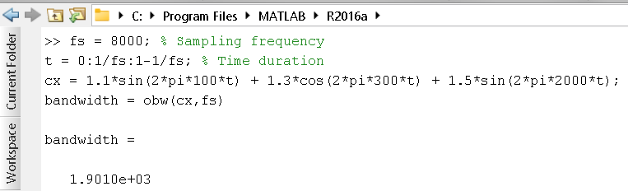

Name: Md. Zahid Hasan
ID: 23- 54242-3
MATLAB Code: Example showing signal processing (noise reduction) is convenient in frequency domain
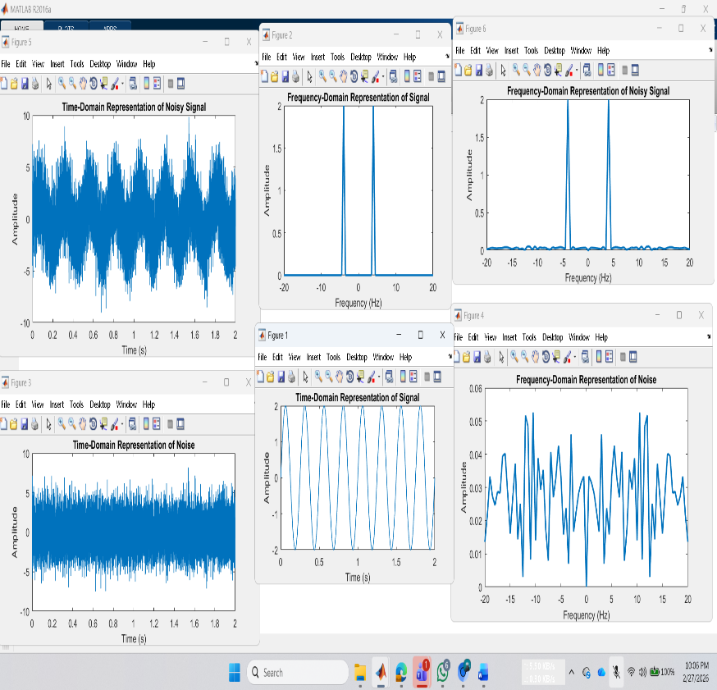
close all;
clc;
%Define number of samples to take
fs = 8000;
f = 4; %Hz
%Define signal
t = 0:1/fs:2;
signal = 2*sin(2*pi*f*t);
nx = length(t); % Total number of samples
%Plot to illustrate that it is a sine wave
plot(t, signal,'linewidth',1);
title('Time-Domain Representation of Signal');
xlabel('Time (s)');
ylabel('Amplitude');
% Take fourier transform
fftSignal = fft(signal);
% Apply fftshift to put it in the form
% we are used to (see documentation)
fftSignal = fftshift(fftSignal)/(nx/2);
% Scaling done by dividing with (fs/2)
% Next, calculate the frequency axis,
% which is defined by the sampling rate
f = linspace(-fs/2,fs/2,nx);
% Since the signal is complex, we need to
% plot the magnitude to get it to
% look right, so we use abs (absolute value)
figure;
plot(f, abs(fftSignal),'linewidth',2);
title('Frequency-Domain Representation of Signal');
xlabel('Frequency (Hz)');
ylabel('Amplitude');
xlim([-20 20])
%noise
sd = 2;
noise = sd*randn(size(signal)); % noise power = sd^2
figure
plot(t,noise, 'linewidth', 1)
xlabel('Time (s)');
ylabel('Amplitude');
title('Time-Domain Representation of Noise');
fftNoise = fft(noise);
fftNoise = fftshift(fftNoise)/(nx/2);
figure
plot(f,abs(fftNoise), 'linewidth', 2)
title('Frequency-Domain Representation of Noise');
xlabel('Frequency (Hz)');
ylabel('Amplitude');
xlim([-20 20])
%noisy signal
noisySignal = signal + noise;
figure
plot(t,noisySignal, 'linewidth', 1)
xlabel('Time (s)');
ylabel('Amplitude');
title('Time-Domain Representation of Noisy Signal');
fftNoisySignal = fft(noisySignal);
fftNoisySignal = fftshift(fftNoisySignal)/(nx/2);
figure
plot(f,abs(fftNoisySignal), 'linewidth', 2)
title('Frequency-Domain Representation of Noisy Signal');
xlabel('Frequency (Hz)');
ylabel('Amplitude');
xlim([-20 20])

Name: Md. Zahid Hasan
ID: 23- 54242-3
MATLAB Code: Example of Quantization using Matlab bulit-in function ‘quantiz’
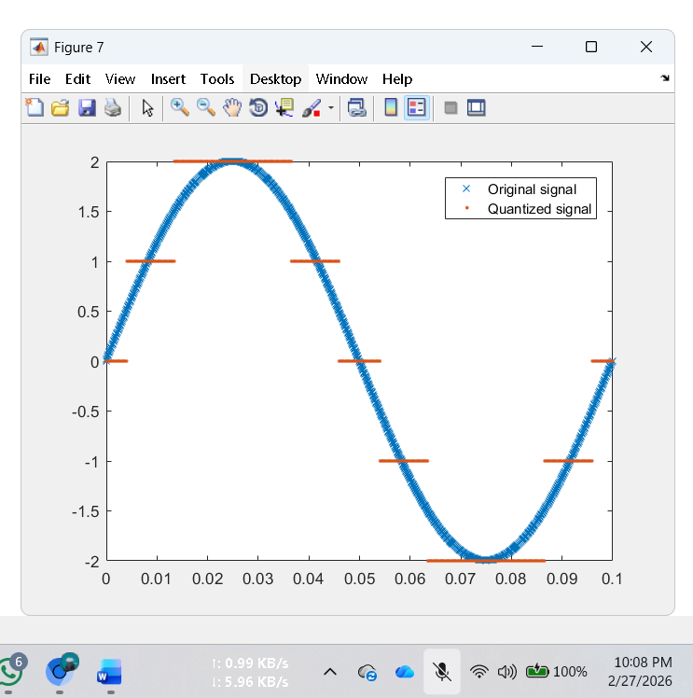
fs = 10000;
t = [0:1/fs:0.1];
f = 10; % Times at which to sample the sine function
sig = 2*sin(2*pi*f*t); % Original signal, a sine wave
partition = -1.5:1.5; % Length 4, to represent 5 intervals
codebook = -2:2; % Length 5, one entry for each interval
[index,quants] = quantiz(sig,partition,codebook); % Quantize.
figure
plot(t,sig,'x',t,quants,'.')
legend('Original signal','Quantized signal');
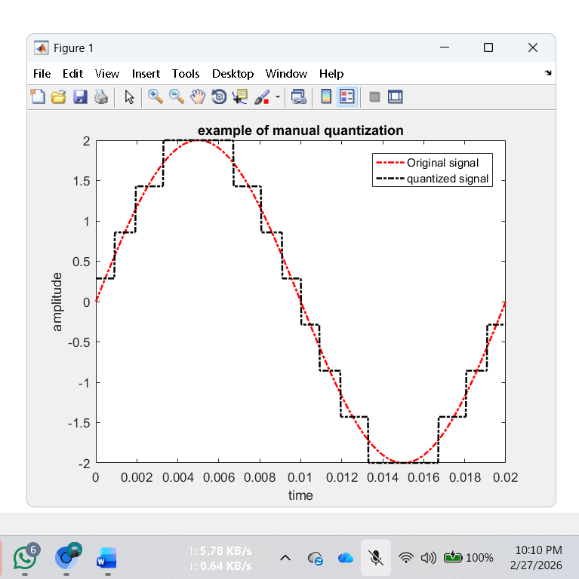
Name: Md. Zahid Hasan
ID: 23- 54242-3
MATLAB Code: Example of Quantization NOT using Matlab bulit-in function
clc
close all
fs = 40e3;% sampling frequency
f = 50;% frequency of the signal
t = 0:1/fs:1/f;%discrete time
A = 2;
x = A*sin(2*pi*f*t);% discrete signal
n = 3;
L =(2^n);
delta=(max(x)-min(x))/(L-1);
xq = min(x)+(round((x-min(x))/delta)).*delta;
plot(t,x,'r-.', 'linewidth',1.5);
hold on;
plot(t,xq,'k-.', 'linewidth',1.5);
%plotting wave forms.
xlabel('time')
ylabel('amplitude')
title('example of manual quantization')
legend('Original signal','quantized signal')

Name: Md. Zahid Hasan
ID: 23- 54242-3
Performance Task: 23- 54242-3
(a) Time and frequency domain representation:
clc;
clear;
close all;
%% Parameters
a1 = 3; a2 = 6; a3 = 5;
f1 = 3; f2 = 6; f3 = 5;
fs = 200;
T = 1;
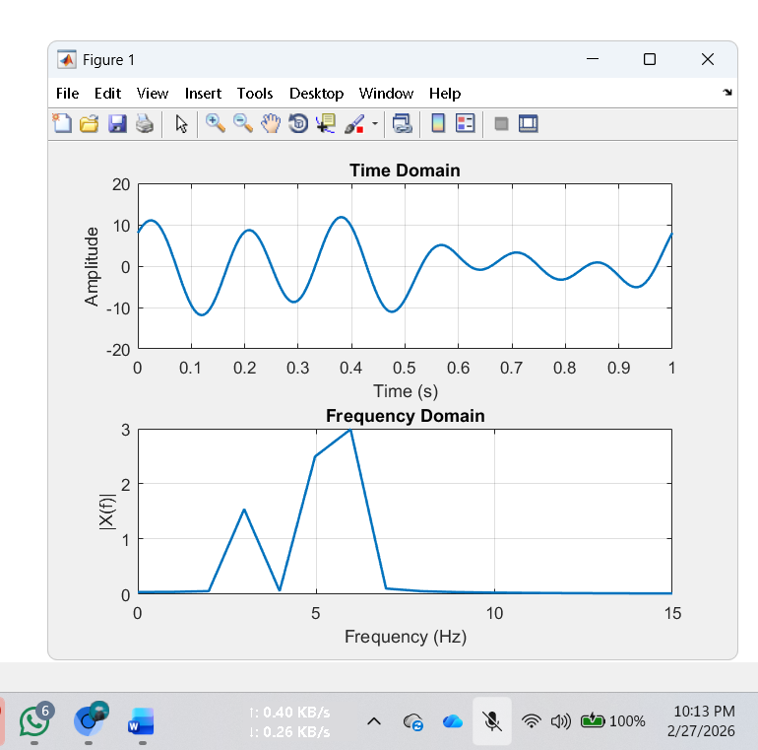
t = 0:1/fs:T;
%% Signal
signal_x = a1*cos(2*pi*f1*t) + ...
a2*sin(2*pi*f2*t) + ...
a3*cos(2*pi*f3*t);
%% FFT
N = length(signal_x);
X = fft(signal_x);
f = (0:N-1)*(fs/N);
%% Plot
figure
subplot(2,1,1)
plot(t, signal_x,'LineWidth',1.5)
xlim([0 1])
grid on
title('Time Domain')
xlabel('Time (s)')
ylabel('Amplitude')
subplot(2,1,2)
plot(f, abs(X)/N,'LineWidth',1.5)
xlim([0 15])
grid on
title('Frequency Domain')
xlabel('Frequency (Hz)')
ylabel('|X(f)|')
Name: Md. Zahid Hasan
ID: 23- 54242-3
(b) Quantization of 4 levels:
clc;
clear;
close all;
%% Parameters
a1 = 3; a2 = 6; a3 = 5;
f1 = 3; f2 = 6; f3 = 5;
fs = 200;
Tcycle = 1/3;
t = 0:1/fs:Tcycle;
%% Signal
signal_x = a1*cos(2*pi*f1*t) + ...
a2*sin(2*pi*f2*t) + ...
a3*cos(2*pi*f3*t);
%% 4-Level Quantization using quantiz()
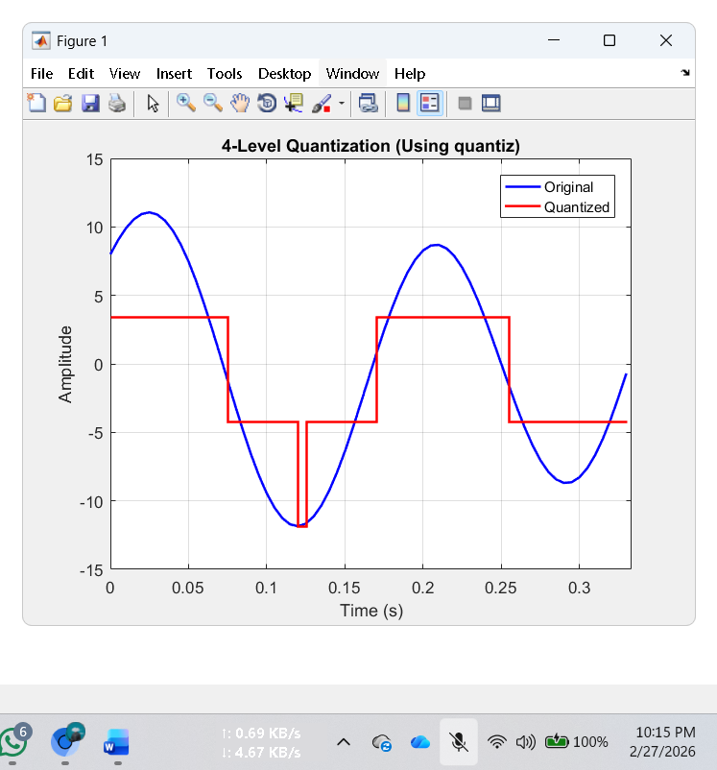
L = 4;
xmin = min(signal_x);
xmax = max(signal_x);
partition = linspace(xmin, xmax, L-1);
codebook = linspace(xmin, xmax, L);
[index, quantized] = quantiz(signal_x, partition, codebook);
%% Plot
figure
plot(t, signal_x,'b','LineWidth',1.5)
hold on
stairs(t, quantized,'r','LineWidth',1.5)
xlim([0 Tcycle])
grid on
title('4-Level Quantization (Using quantiz)')
xlabel('Time (s)')
ylabel('Amplitude')
legend('Original','Quantized')
Name: Md. Zahid Hasan
ID: 23- 54242-3
(c) Quantization of 8 levels:
clc;
clear;
close all;
%% Parameters
a1 = 3; a2 = 6; a3 = 5;
f1 = 3; f2 = 6; f3 = 5;

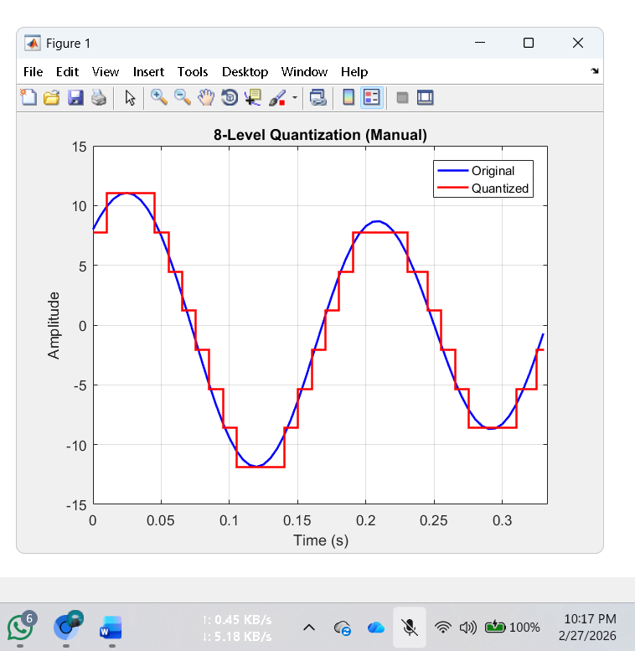
fs = 200;
Tcycle = 1/3;
t = 0:1/fs:Tcycle;
%% Signal
signal_x = a1*cos(2*pi*f1*t) + ...
a2*sin(2*pi*f2*t) + ...
a3*cos(2*pi*f3*t);
%% 8-Level Quantization (Manual)
L = 8;
xmin = min(signal_x);
xmax = max(signal_x);
delta = (xmax - xmin)/(L-1);
quantized = xmin + round((signal_x - xmin)/delta)*delta;
%% Plot
figure
plot(t, signal_x,'b','LineWidth',1.5)
hold on
stairs(t, quantized,'r','LineWidth',1.5)
xlim([0 Tcycle])
grid on
title('8-Level Quantization (Manual)')
xlabel('Time (s)')
ylabel('Amplitude')
legend('Original','Quantized')

